

For safety and efficiency reasons, Palliser Regional Schools would like to reduce the amount of Cash & Checks coming into our school. Please join the thousands of parents who have already registered and are enjoying the convenience of paying ONLINE! It takes less than 5 minutes to register. Please follow these step-by-step instructions, so you will begin to receive email notifications regarding upcoming events involving your child(ren).
NOTE: If you require assistance, select the GET HELP option in the top right hand corner of the screen.
Step 1: Register
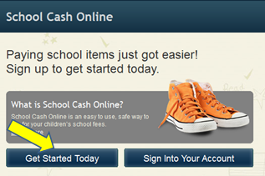
- If you have not registered, please go to the School Cash Online home page https://palliserregional.schoolcashonline.com/
and select the “Get Started Today” option.

- Complete each of the three Registration Steps
*For Security Reasons your password, requires 8 characters,
one uppercase letter, one lowercase letter and a number.

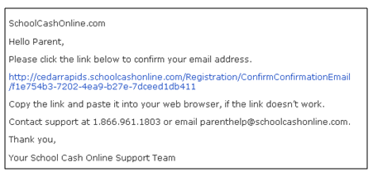
Step 2: Confirmation Email

A registration confirmation email will be forwarded to you. Click on the link provided inside the email to confirm your email and School Cash Online account.
The confirmation link will open the School Cash Online site prompting you to sign into your account. Use your email address and password just created with your account.
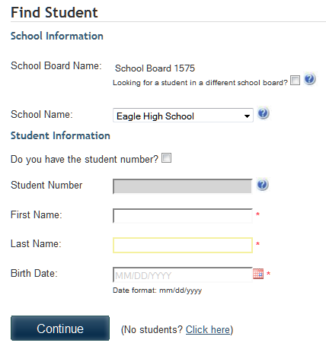
Step 3: Find Student
Note: Student Number is Not Required
This step will connect your children to your account.
- Enter the School Board Name
- Enter the School Name
- Enter Your Child’s Name & Birth Date
- Select Continue
- On the next page confirm that you are related to the child, check in the Agree box and select Continue
- Your child has been added to your account

Step 4: View Items or Add Another Student

If you have more children, select “Add Another Student” option and repeat the steps above. 5 children can be added to one parent account.
If you do not wish to add additional children, select
“View Items For Students” option. A listing of available items for purchase will be displayed.

