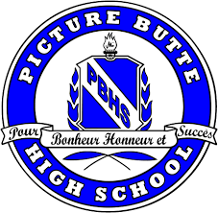

School Supply List

- One 2”-3” Binder/Subject
- Three packages of Dividers
- Paper, pens, pencils (2H – 4H), and Whiteout
- Self containing pencil sharpener
- Three highlighters of different colours
- USB Key (8 Gigabyte size and up)
- One package of pencil crayons (optional)
- One Geometry set
- One pair scissors
- One glue stick
- One scientific calculator (Math 8/9) OR TI-83 or higher (for Math 10C and up)
- One package graph paper
- One lock for locker (can be rented from school as well)
- One set of Gym attire (shirt, shorts, shoes)
- Dictionary and thesaurus

